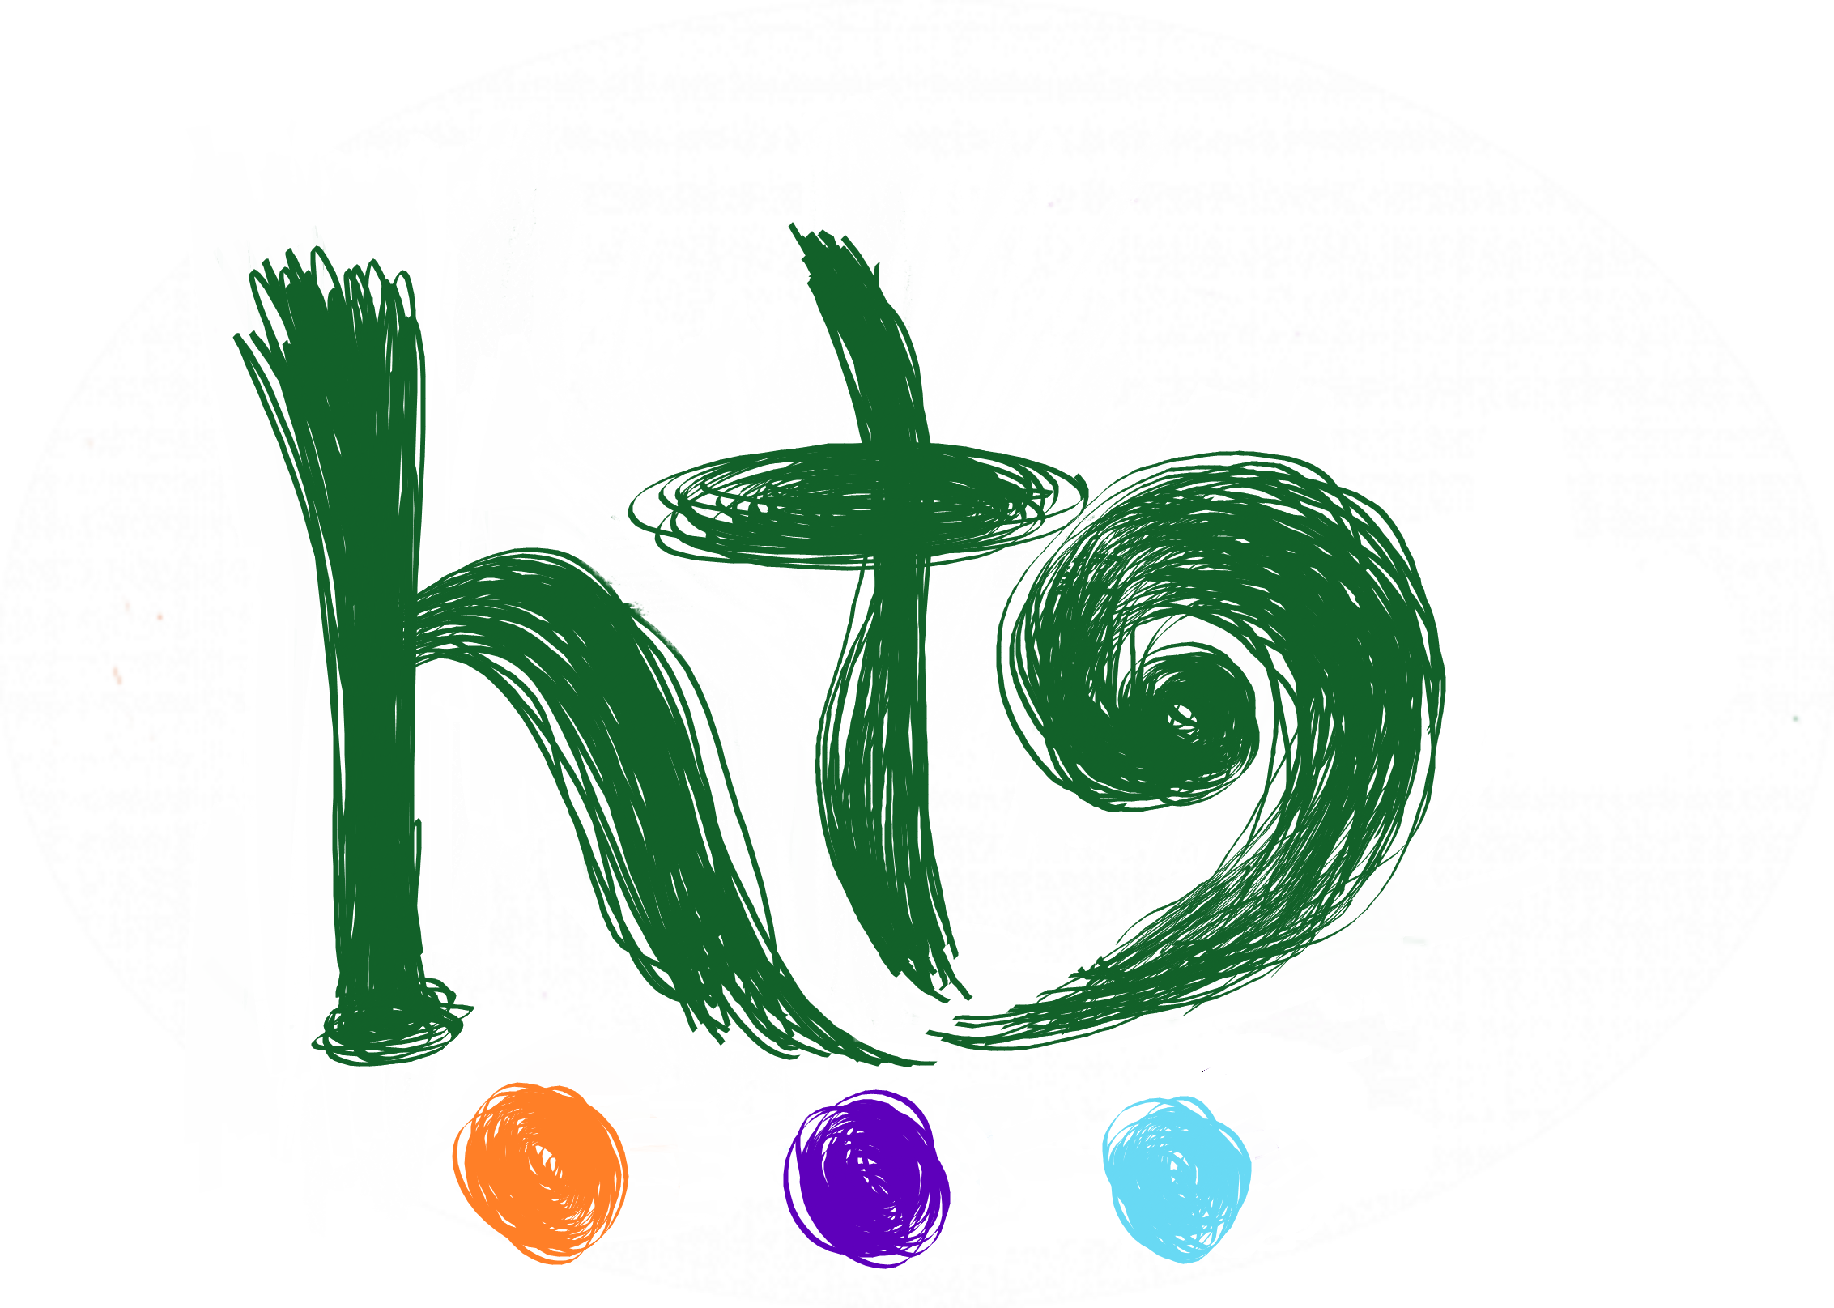Healing Through Arts  A means to healing & growth …  Date of Referral: |  |  | REFERRAL FORM  admin@htatherapy.com M:0423 748 060  If client under 16 years, have they consented to referral? □ Yes □ No
Clients NDIS Number: Support Plan dates:
If applicable
□ Self-Managed  □ Plan-Managed  □ Private | (If Plan Managed)  Plan Manager:  Email:  Phone:
CLIENT NAME: |  | DOB: |  | Gender: □Male □Female  □ Other/Specify
CLIENT ADDRESS: |  | Client Phone:  Client Email:
SUPPORT CO-ORDINATOR NAME: |  | PH: |  | Email:
Please Describe the Living Arrangements:  - Lives Alone  - Lives with Family  - Supported Living  - Other ____________________________ |  | Is there a contact for the living arrangement?  Name:  Ph:
EMERGENCY CONTACT NAME: |  | RELATIONSHIP:
 |  | CONTACT PHONE:
REFERRER DETAILS
Name: Organisation and Position:

Phone: Email:

REFERRAL SERVICE:
NDIS Non NDIS (Private) □
Capacity Building □ Core □
Therapeutic Supports □
Participate in Community □
Innovation Community Participation □
Development-Life Skills □

DETAILS FOR REFERRAL

Reason for referral and expected outcomes?

History of client
Please note: Please include sufficient and all relevant information in your referral to avoid us contacting you needing further details

Diagnosis’:

Allergies:

Risks: (please complete)
Known Triggers and strategies used:

Family Dynamics:

Indigenous/Cultural Identity:

Client details for Art Therapy

Strengths:

Interests:

Dislikes:

Challenges:

Please provide a copy of the participants NDIS Goals (if applicable) along with referral:

Preferred location for Art Therapy:
□ Precinct Wellbeing Hub Smithfield Plains SA
□ Home Visit (if Therapist available)
□ Online Art Therapy Session

